MODERN SEARCH LANDSCAPE
Tasks
1.Open YouTube and search for 'How to make Dalgona coffee'. Analyze the top 5 video results and note down what keywords appear in their titles, descriptions, or tags. List the most common keywords you find.
=> How to Make Dalgona Coffee ?
Common Keywords Found :
- Dalgona Coffee
- Easy Recipe
- Homemade
- Coffee
- Whipped Coffee

2.Go to Amazon.in and search for 'wireless earbuds'. Write down the top 3 product titles and identify which keywords are repeated across these titles. Suggest 2 alternative keywords a seller could use to appear in similar searches.
=> Top 3 Product Titles:
1. boAt Airdopes 141 Wireless Earbuds
2. Noise Buds VS104 Wireless Earbuds
3. Boult Audio Z40 True Wireless Earbuds
=> Repeated Keywords:
- Wireless
- Earbuds
- True Wireless
=> Suggested Keywords:
- Bluetooth Earbuds
- Noise Cancelling Earbuds
3.Use your phone’s Google Lens or Pinterest Lens to visually search for any item in your room (e.g., a sneaker, book, or snack). Take a screenshot of the visual search results and describe how the search engine interprets your image to suggest products or information.
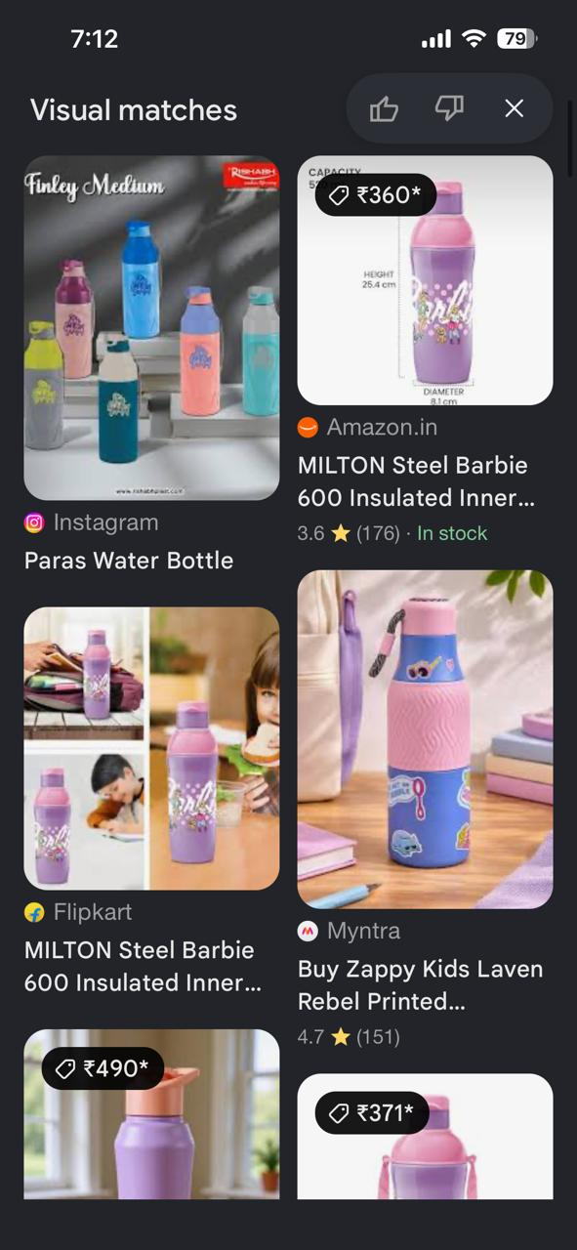
- Google Lens recognized the object as a reusable water bottle. It suggested similar products, online shopping links, and related images based on the shape, color, and design of the bottle.

4.Try a voice search on your phone using Google Assistant or Siri for 'best pizza near me'. Note the exact phrase you spoke and compare the results with a typed search for the same query. List any differences in the results or the way information is displayed.<br><br><em><strong>Hint:</strong> Pay attention to featured snippets, map packs, or direct answers.</em>
=> Voice Search: “Best pizza near me”

Comparison:
- Voice search showed nearby pizza restaurants with maps and ratings.
- Typed search displayed restaurant websites, maps, and additional search results.
- Both searches provided similar information, but voice search gave faster local results.

5. Explain what a Zero-click search is, and give 2 more examples of queries that show Zero-click results.
=> A Zero- Click Search is a search result where Google provides the answer directly on the search results page, so users do not need to click on any websites.
=> 1. IPL Live Score
2. Weather Today

